AIR University Islamabad (AUI)
Assignment-02

CLO-2

Software Requirement Specification
(SRS DOCUMENT)

for
Project Title
(Valid Title reflecting scope and objectives)

Version 1.0

Submitted By:
Student Name 1 Muhammad Hamza Khan
Registration # :- 2502941
Student Name 2 Awais Bajwa
Registration # :- 2502857
BSSE-2-A

Supervisor
Sir Zulfiqar Ali

Bachelor of Science in Software Engineering (2025-2029)

Table of Contents

Table of Contents
1. Introduction 3
1.1 Purpose 3
1.2 Scope 3
1.3 Modules 4
1.4 Overview 4
2. Overall Description 4
2.1 Product Perspective 4
2.2 User Classes and Characteristics 5
2.3 Operating Environment 5
2.4 Design and Implementation Constraints 5
3. Requirement Identifying Technique 6
3.1 Use Case Diagram 6
4. Functional Requirements 8
4.1 Use Case List 8
4.2 Use Case Tabular Details 11
4.3 Functional Requirements 13
5. Non-Functional Requirements 14
5.1 Reliability 14
5.2 Usability 14
5.3 Performance 14
5.4 Security 14
6. External Interface Requirements 15
6.1 User Interfaces Requirements 15
User requires the following list; 15
6.2 Software Interfaces 15
6.3 Hardware Interfaces 15
6.4 Communications Interfaces 16
7. Conclusion 16

- Introduction
The introduction provides a comprehensive overview of the digital transformation of gym management for the AUI community.

1.1 Purpose
The purpose of this Software Requirements Specification (SRS) document is to define the requirements for the Gym Fitness and Tracker Portal. This document is intended for multiple stakeholders involved in this project.
For developers: This SRS serves as a guide for understanding features and functionalities that need to be implemented. It provides use cases and technical specifications for coding and system design.
For trainers and end users: It explains what the system offers and how they can use it to achieve fitness goals they intend to have. It also serves as a reference for documentation writers creating user manuals.

1.2 Scope
The Gym Fitness and Tracker Portal is a web-based application that helps users manage their fitness routine. It solves these problems:
- Clients cannot easily communicate with trainers for guidance
- People fail to calculate calorie intake and protein requirements
- Exercising alone without progress tracking leads to loss of motivation
- Users only track weight, ignoring body fat and muscle mass
- Without proper demonstration, users perform workouts incorrectly
- Most people lack defined fitness goals
- Users track BMI, weight, calories separately making analysis hard
- No feedback on performance improvement
Proposed Solution:
- Direct communication between client and trainer
- Diet and nutrition tracking with automatic calorie calculation
- Visual progress tracking with graphs and reports
- Monitor multiple health indicators (BMI, body fat, weight)
- Set specific fitness goals (weight loss, muscle gain)
- All data stored in one centralized system
- Trainers can monitor client progress

1.3 Modules
- Module 1: User Management
Handles registration, login, and profile management for trainers and clients.
- Module 2: Workout Management
Trainers create and assign workout plans. Users track their daily exercises.
- Module 3: Progress Tracking & Data Visualization
Monitors fitness progress through charts and graphs for BMI, weight, and performance.
- Module 4: Nutrition & Diet Tracking
Tracks calorie intake, protein, and nutrients according to fitness goals.
- Module 5: Trainer-Client Communication
Messaging system for guidance, feedback, and workout corrections.
- Module 6: Exercise Tutorial
Provides instructional videos and guides for correct exercise techniques.

1.4 Overview
Section 1 introduces the document. Section 2 has a product overview. Section 3 describes the requirement technique. Section 4 contains functional requirements. Section 5: Non-functional Requirements Section 6 describes external interfaces. Section 7 concludes. Section 8 lists references. Section 9: Give plagiarism report.

- Overall Description

2.1 Product Perspective
This is a new product that combines multiple fitness tracking features into one platform. Existing apps have limitations:
App | Weakness
MyFitnessPal | Focuses only on diet, no trainer guidance
JEFIT | Too complicated for beginners
Fitbod | Uses AI but won't fix your posture or form
Our system integrates diet, workouts, and trainer-client communication with a simple, clean design.

2.2 User Classes and Characteristics
User Class | Description
Client | Gym member who tracks workouts, diet, and progress. Needs an easy-to-use interface.
Trainer | Fitness professional who creates plans and guides clients. Needs to manage multiple clients.
Admin | Manages user accounts, trainers, and system content.

2.3 Operating Environment
OE-1: Works on Chrome, Firefox, Safari, Edge (latest versions)
OE-2: Accessible on desktops, laptops, tablets, and mobile phones
OE-3: Works on Windows 10+, macOS 11+, iOS 14+, Android 10+
OE-4: Requires an internet connection
OE-5: Runs on Apache/Nginx with MySQL database

2.4 Design and Implementation Constraints
CON-1: Web-based using HTML5, CSS3, JavaScript
CON-2: Uses Bootstrap 5 for responsive design
CON-3: Backend in PHP or Node.js with MySQL
CON-4: SQL for database queries
CON-5: Password encryption using bcrypt
CON-6: Simulated payment processing (no live banking APIs)
CON-7: Videos stored locally, not streamed from external platforms
CON-9: Agile methodology for development
CON-10: Object-Oriented Design for modularity

- Requirement Identifying Technique
We used the Use Case technique because this is an interactive end-user application.

3.1 Use Case Diagram
- Client Use Cases:
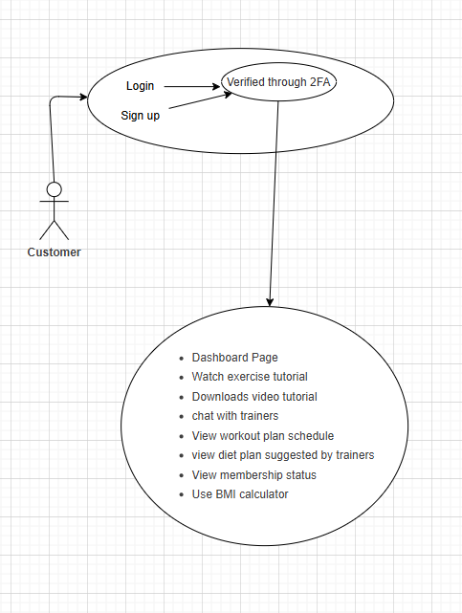

- Trainer Use Cases:
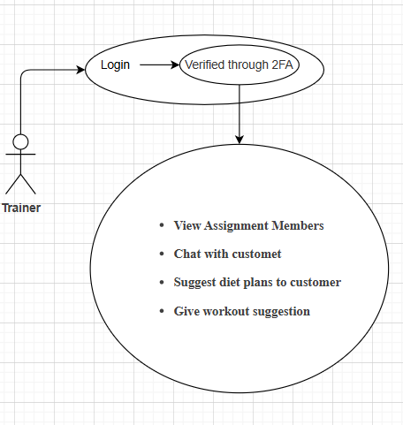
- Admin Use Cases:
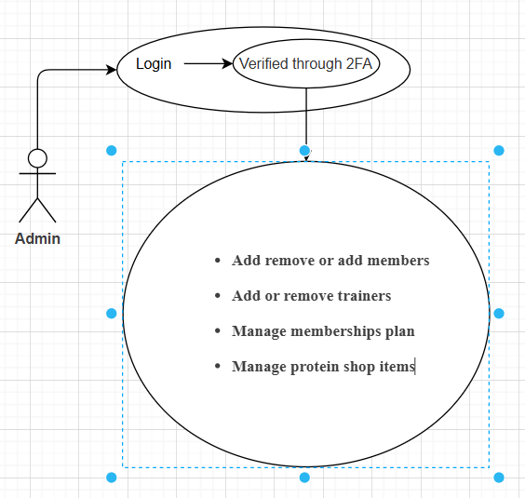

- Functional Requirements

4.1 Use Case List
- Module 1: User Management
ID | Use Case
UM-UC1 | Register New Account
UM-UC2 | Log in to System
UM-UC3 | Update Profile
UM-UC4 | Change Password
UM-UC5 | Recover Password
UM-UC6 | View Profile
UM-UC7 | Logout
- Module 2: Workout Management
ID | Use Case
WM-UC1 | Create Workout Plan
WM-UC2 | Assign Plan to Client
WM-UC3 | View Assigned Plan
WM-UC4 | Mark Exercise Complete
WM-UC5 | Track Workout History
WM-UC6 | Update Workout Plan
WM-UC7 | Delete Workout Plan
- Module 3: Progress Tracking
ID | Use Case
PT-UC1 | Log Body Measurements
PT-UC2 | Calculate BMI
PT-UC3 | View Weight Chart
PT-UC4 | View BMI History
PT-UC5 | View Performance Graph
PT-UC6 | Generate Progress Report
- Module 4: Nutrition Tracking
ID | Use Case
NT-UC1 | Log Daily Food Intake
NT-UC2 | Track Calories
NT-UC3 | Track Protein
NT-UC4 | Track Macronutrients
NT-UC5 | View Nutrition Summary
NT-UC6 | Get Diet Recommendations
Module 5: Communication
ID | Use Case
TC-UC1 | Send Message to Trainer
TC-UC2 | Send Message to Client
TC-UC3 | View Message History
TC-UC4 | Provide Feedback
TC-UC5 | Receive Guidance
TC-UC6 | Share Progress with Trainer
Module 6: Exercise Tutorial
ID | Use Case
ET-UC1 | Browse Tutorials
ET-UC2 | Search by Category
ET-UC3 | View Tutorial Video
ET-UC4 | Read Instructions
ET-UC5 | View Equipment Requirements
ET-UC6 | Save Favorite Tutorials

4.2 Use Case Tabular Details
Use Case: Register New Account (UM-UC1)
Field | Description
Use Case ID | UM-UC1
Name | Register New Account
Actors | Client, Trainer,admin
Description | User creates account by providing name, email, password, age, weight, height, and  fitness goals
Trigger | User clicks "Sign Up."
Preconditions | User has internet and valid email
Postconditions | Account created, user logged in, welcome email sent
Normal Flow | 1. User clicks Sign Up  2. System shows registration form  3. User fills details  4. System validates  5. System checks if email exists  6. System encrypts password  7. System creates account  8. User redirected to dashboard
Alternate Flow | Register as Trainer - shows extra fields for certification
Exceptions | Email already exists, passwords don't match, weak password
Use Case: Send Message to Trainer (TC-UC1)
Field | Description
Use Case ID | TC-UC1
Name | Send Message to Trainer
Actors | Client, Trainer
Description | Client messages trainer for guidance or questions
Trigger | Client clicks "Message Trainer"
Preconditions | Client logged in, has assigned trainer
Postconditions | Message saved, trainer notified
Normal Flow | 1. Client opens messages  2. Types message  3. Clicks Send  4. System saves message  5. Trainer gets notification
Exceptions | Empty message, file too large

4.3 Functional Requirements
ID | Title | Requirement | Priority
FR-1 | User Registration | System shall allow users to register with name, email, password, age, weight, height, goals | High
FR-2 | BMI Calculation | System shall calculate BMI = weight(kg)/(height(m))² and show category | High
FR-3 | Workout Tracking | System shall track completed exercises, sets, reps, and weight used | High
FR-4 | Messaging | System shall provide messaging between client and trainer | Medium
FR-5 | Calorie Tracking | System shall track daily calorie intake and compare with goals | Medium
FR-6 | Tutorial Videos | System shall provide exercise tutorial videos with instructions | Medium
FR-7 | Progress Charts | System shall show progress through interactive charts and graphs | Medium
FR-8 | Goal Setting | System shall allow users to set and track fitness goals | Medium
FR-9 | Admin Dashboard | System shall provide an admin interface to manage users and content | Low

- Non-Functional Requirements

5.1 Reliability

- 99% uptime during peak hours (6 AM - 10 PM)
- Daily backups, restorable within 2 hours
- Handles 500 concurrent users
- Validates all inputs to prevent data corruption

5.2 Usability
- New users can register within 3 minutes
- All functions accessible within 3 clicks
- Error messages in plain language
- Responsive on all devices
- Consistent color coding: green (completed), yellow (warning), red (error), blue (interactive)

5.3 Performance
- 95% of pages load within 3 seconds
- Database queries under 500 milliseconds
- Charts generated within 2 seconds
- Messages delivered within 2 seconds
- Search results within 1 second

5.4 Security
- Passwords hashed with encryption
- Password must be 8+ chars with uppercase, lowercase, number, special characters
- Session timeout after 30 minutes
- Role-based access control
HTTPS with TLS 1.2+
- Protection against SQL injection, XSS, CSRF
- 5 failed login attempts = 30-minute lock

- External Interface Requirements

User Interfaces Requirements

User requires the following list;
- Consistent design with blue, green, orange color scheme
- Sans-serif fonts (Arial, Helvetica)
- Navigation at top (desktop) or hamburger menu (mobile)
- Primary buttons in orange, secondary in gray, delete in red
- Forms with labels, placeholders, real-time validation
- Dashboard with metric cards and icons
- Interactive charts with hover details
- Mobile touch targets minimum 44x44 pixels

6.2 Software Interfaces
- MySQL Database: Stores all data
- File Storage: For profile pics, videos, attachments
- Email Service: Sends welcome emails, notifications
- Chart Library: Chart.js or D3.js for graphs

6.3 Hardware Interfaces
- Standard input devices (keyboard, mouse, touch)
- Touch gestures supported on mobile
- Compatible with all standard displays

6.4 Communications Interfaces
- HTTP/HTTPS with TLS encryption
- AJAX for smooth user experience
- WebSocket or polling (5 sec) for real-time messaging
- SMTP for emails

- Conclusion
The Gym Fitness and Tracker Portal is a web-based application that solves common fitness problems: poor trainer communication, lack of progress tracking, incorrect workout techniques, and undefined fitness goals. The system has six modules working together to provide a complete solution. This SRS document will guide development, testing, and implementation. The project will help us learn full-stack development, database management, and API integration while creating something useful for gym members and trainers.

